New Patient Medical Questionnaire
ADULTS and CHILDREN over 12 years of age

To register with this practice, please complete this questionnaire as fully as possible. It can take some time for your previous medical records to reach us. The information you give in this questionnaire will help us to provide you with good medical care.

PERSONAL DETAILS
Title | Mr / Mrs / Miss / Ms | Have you been registered here before? |  |  | Yes No
Surname |  | Forename(s) |  |  | Male Female
Previous Name |  | Occupation
Home Tel: |  | Mobile:
Work Tel |  | Email:
Name of School (if aged 12-18 years):
Emergency Contact Name: |  | Relationship: |  | Tel:
Next of Kin: |  | Relationship: |  | Tel:
Status | Single Married Separated Divorced Widowed Cohabiting

HEALTH DETAILS
Blood pressure | / |  | Height |  | Weight
Do you smoke? | Yes No
If yes, are you interested in giving up smoking? Yes No |  |  |  | Yes No
If not a smoker, have you ever smoked? Yes No |  |  |  | Yes No
If YES, when did you START? |  |  |  | When did you STOP?
How many per day? |  | Cigarettes: Cigars: Pipe:
Alcohol – Alcohol use can affect your health and interfere with certain medications and treatments. Your answers will remain confidential so please be honest.
Use the guide below to decide how many UNITS you drink a week.
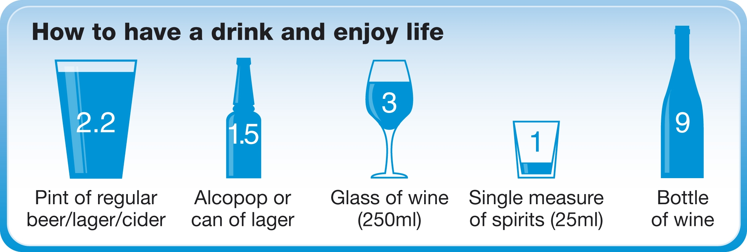 |  |  |  | Do you drink any alcohol?  How many units / week? |  |  | Yes No
Drugs – Do you have a drug addiction? |  |  |  | Yes No
Exercise – Do you take exercise? |  |  |  | Yes No
On average, how many sessions of moderate or vigorous activity of twenty minutes or more duration do you usually do each week? |  |  |  | sessions

MEDICAL HISTORY
Do you have, or have you had, any serious health problems (including operations) or long-term conditions?
 |  | Details |  |  | Date (if known)
Asthma
Cancer
COPD
Chronic kidney disease
Diabetes
Epilepsy
Heart attack/disease
High blood pressure
High cholesterol
Osteoporosis
Stroke
Mental health problems
Underactive thyroid
Circulation problems
Other serious illness
Any operations
Any known allergies | Yes No If yes, please list.
Allergic to: |  |  | Type of reaction:
Allergic to: |  |  | Type of reaction:

REPEAT MEDICATION
Are you on any medicines at present? | Yes No
If you are on regular medication, please provide a recent printout (less than two months old) of your medication to Reception and we will arrange for the items to be set up on our clinical system.
If you do not have a printout, please ask for a doctor’s appointment to discuss this.
Do you take any other over-the-counter medication? If so please list:

Immunisation history
Routine childhood immunisations
 | Age usually given | Date Given |  |  |  | Indicate if declined
Human Papillomavirus vaccine (HPV) | 12-18 yrs (♀only) | 1st | 2nd |  | 3rd
5th Diphtheria, tetanus, polio (School leavers booster) | 13- 18 years
Meningitis C (Men C)
Other immunisations – attach copies if you have them
Vaccination |  |  |  | Date Given

ELECTRONIC PRESCRIPTION SERVICE (EPS)
The Electronic Prescription Service (EPS) is an NHS service. You will not have to visit the GP practice to pick up your paper prescriptions. Instead, your GP will send it electronically to your nominated Pharmacy. (An information sheet is included in your new patient pack with full details.)
Please indicate your preference below:
I would like my repeat prescriptions sent electronically to: | Pharmacy  Branch

FAMILY MEDICAL HISTORY
Have any of your immediate relatives (brothers/sisters/parents) had any of the following:
 |  | Details | Relationship | Date (if known)
Heart attack or angina before age 60
Heart attack or angina over age 60
Asthma
Diabetes
Stroke
Cancer
Any inherited diseases

FEMALES ONLY
Date of last cervical smear? |  |  |  | Are you pregnant? |  |  | Yes No
Where was it taken?
What was the result?
Have you had a hysterectomy? |  |  |  |  |  |  | Yes No
Contraception – what is your current method of family planning?
None |  |  | Coil |  |  | Injection
Contraceptive Pill |  |  | Sterilisation |  |  | Implant
Condom |  |  | Partner had vasectomy |  |  | Hysterectomy

CARERS
Do you look after an elderly or sick relative or friend? | Yes No
If YES, please indicate relationship:

Ethnicity – How would you describe your ethnicity?
White | British | Irish |  | Other white
Asian | Asian British | Bangladeshi |  | Indian |  | Pakistani | Other Asian
Black | Black British | African |  | Caribbean |  | Oher black
Mixed | Asian & White | Asian & Black |  | Asian & Caribbean |  | White African | White Caribbean
Other | Chinese | Japanese |  | Middle Eastern |  | Other (please state)
Country of Birth:
Do you speak English? |  |  | Yes No |  | First Language (if not English):

DATA SHARING

Communication within the NHS is important to ensure that those who are caring for you have enough information to treat you safely. Traditionally health professionals exchanged medical information through letters, but in the modern age of computers, electronic exchange of information has become increasingly commonplace.

The Manor Surgery takes responsibility for your confidential medical information very seriously. This form offers you the opportunity to express your wishes as to whether or not you would like your medical record to be shared. In addition you can consent to receiving reminder text messages and if you would like to access our online services.

PERSONAL DETAILS
Surname: |  | First Name |  | Date of Birth

SUMMARY CARE RECORD (SCR) AND OXDFORDSHIRE CARE SUMMARY (OCS)
The NHS in England has introduced the Summary Care Record, which will be used in emergency care.
The record will only contain information about any medicines you are taking, allergies you suffer from and any bad reactions to medicines you have had to ensure those caring for you have enough information to treat you safely.
Your Summary Care Record will be available to authorised healthcare staff providing your care anywhere in England, but they will ask your permission before they look at it, if possible. This means that if you have an accident or become ill, healthcare staff treating you will have immediate access to important information about your health.
The Oxfordshire Care Summary is an electronic view of specific, up-to-date, clinical information from your GP record and other records which may be kept to support your care in NHS organisations in Oxfordshire.
As a patient you have a choice. Please indicate your preference below:
For further information visit the website www.nhscarerecords.nhs.uk, or telephone the dedicated NHS Summary Care Record Information Line on 0300 123 3020.
Do you wish to have a Summary Care Record? |  |  | Yes No
Do you wish to have an Oxfordshire Care Summary? |  |  | Yes No
Signature |  | Date

COMMUNICATION VIA TEXT MESSAGE (SMS)
The practice uses text messages to communicate with patients. Examples of information that may be sent by text message are:
- Administrative information e.g. prescription ready to collect
- Care plan sent in a consultation e.g. dosing of new medication
- Recall e.g. advising the patient to book an appointment
- Advice and safety netting sent in a consultation e.g. link to NHS Choices information
- Signposting to third-party services in a consultation e.g. exercise classes
- Normal test results e.g. Chest x-ray normal
- Some abnormal results e.g. Low Vitamin D, with advice for sun exposure and OTC supplements
- Telephone information e.g. you tried to call but could not reach them, or will be calling
- Reminders e.g. for cervical screening or overdue blood tests
- Follow-up e.g. checking a patient has received a hospital letter after a referral
The following information will not be sent by text message:
- Worrying, complex or sensitive test results – the Doctor will contact you directly by telephone or send you a letter about this sort of information.
- Long or complex messages e.g. multiple medication changes
- Links to sensitive patient advice without consent e.g. family planning advice
- Signposting to third-party services without consent e.g. Macmillan contact details
- Critical information without follow-up e.g. urgent appointment required
Please indicated whether you consent to communication via text message below. Please note that you may opt out of receiving text messages from the practice at any time.
Do you wish to receive text messages from the practice? |  |  | Yes No
If yes, please confirm your mobile telephone number for communication
Is this your own telephone number of the number of a nominated person? |  |  | Own Other
If it is the number of a nominated person, please state their name and relationship to you
Signature |  | Date

Accessing appointment booking and repeat prescribing online

The NHS App
You can now make appointments and order repeat prescriptions online via the NHS App.

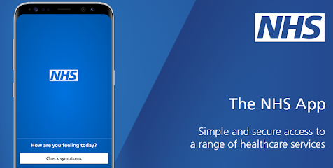

The NHS App is for patients aged 13 years and over and is free to download from the App Store and Google Play.

With the NHS App you can:
- book appointments – search for, book and cancel appointments at your GP surgery
- order repeat prescriptions – see your available medications and request a new repeat prescription
- view your medical record – get secure access to your GP medical record
- register to be an organ donor – easily manage your preferences on the NHS Organ Donor Register
- choose how the NHS uses your data – register your decision on whether it can be used for research and planning
Go to www.nhs.uk/apps-library/nhs-app/ to download the app. You will need to set up an account and verify your identity by scanning in a photo id and using their face recognition software. If you have any queries or require any help registering for the NHS app then please speak to a member of our reception team who will be happy to help.

Patient Access
If you don’t have a smart phone but have access to the internet, you can make appointments and order repeat prescriptions online via Patient Access at www.patientaccess.com . You will need to complete a registration form and verify your identification at the practice. Please ask a member of the reception team for an application form of for more information.

